500 Word Report

During my brainstorming process, I decided that I could visualise data either from music or movies, they are two things that I am very interested in and I thought they could both be fun to visualise. To get some inspiration I started my research into digital artists who have used data to create something interesting. Peter Cronkraks diagram ‘Love will tear us apart again’ represents the ‘emotional impact’ of the song by Joy Division. He looked at how it affects people in different countries and how there were different interpretations of the song. This reminded me of sound waves and I thought that this could be an interesting way of visualising music data. So I started to look for some RSS feeds for the top 40. I did however come across various issues with this, and kept getting certain error codes in the console. Due to this I continued my research to see if I could get some other inspiration as to how I could visualise movie data instead of music.

The Heart Bot is a collaboration between Sid Lee NY, Tool and Intel. It tracks the user's heart rate and uses that data to draw onto a wall, creating a ‘piece of spontaneous and interactive art’. The final piece was several heart rates that showed ‘each person's unique physiological response to their environment’ I think that this is an extremely cool concept and that it shows how amazing things can be created through technology.

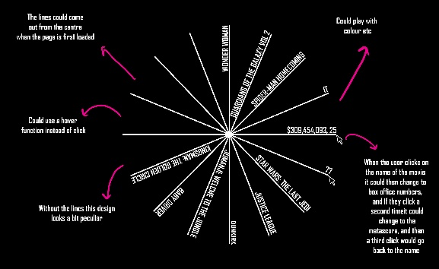Aaron Koblin specialises in data and digital technologies, he’s known for his use of data visualisation and work in crowdsourcing and interactive film. He thinks that ‘data can make us more human’. His project Flight Patterns, visualises airline flights over North America in a 24-hour period. It’s something that is very interesting to look at and also provides some important information. After this research, I did some sketches for my ideas for how I could visualise the movie data. I decided that I want to create something quite simplistic and functional, but still aesthetically pleasing.

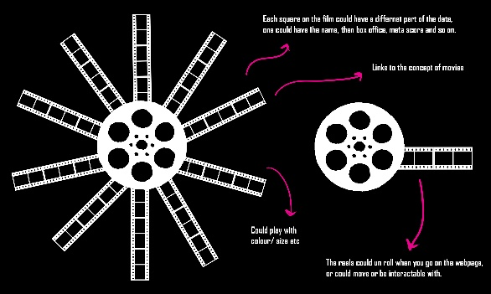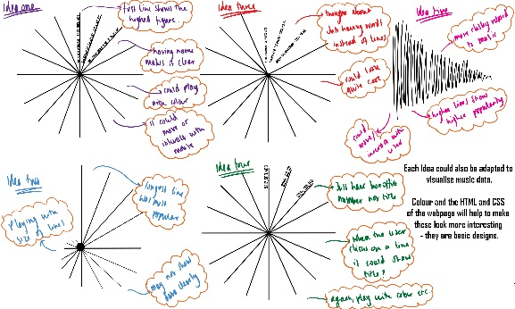

I was able to find the data that I wanted using an apiKey and IMDB’s information that they have on their site. I will use the movies name and box office number. To make the webpage look more interesting I used photoshop to create an image which had characters from each movie. I had issues when trying to add this to my code originally, I set is as a background in css, but quickly realised that the text was then loading incorrectly on the screen, so I then added the image through javascript. During the coding process, I came across several issues, and I had to try out various methods to get the affect I wanted. I ended up using boolean switches to allow the title of the movie to change when the user interacts with the webpage. Due to the angles, I had to use circles to plot the radius of the mouseX and mouseY points, I found it quite challenging to start with but at the end I was proud of what I had created.

<https://github.com/elloella>

elloella.github.io

References:

<https://techcrunch.com/2016/05/08/the-digital-age-of-data-art/> - Peter Crnokrak

<https://iq.intel.com/turning-data-visualization-art-7-artists-using-data-muse/> - The Heart Bot

<https://flowingdata.com/2017/12/21/ed-sheerans-creative-process-explained-with-music-visualization/>

<https://medium.com/@Infogram/meet-6-artists-who-have-swept-data-art-into-the-digital-age-d5c5ae805bab> - Aaron Koblin